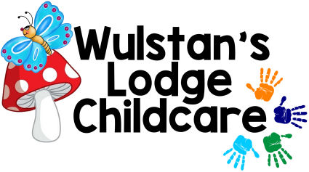
Name of Child/ren & Age
…………………………………………………………………………………………………………………………………………………………………………………………………………
Don’t forget your packed lunch and water bottle.
This Photo by Unknown Author is licensed under CC BY-NC
Summer Holiday Club 2021
All Children aged 2-11 years welcome
Join us for three action-packed weeks filled with fun, adventure, and exciting activities.
Activities include: ‘Cardboard Chaos’, Mask Making, Baking & Cooking, Puppet Making, Face Painting & Hair Braiding, Bring Your Wheels Days, Picnic in the Park, Games and sports, Arts & Crafts, Water Battles, Treasure Hunts and Many More.
Planet Rangers

Monday 02nd August 2021
Tuesday 03rd August 2021
Wednesday 04th August 2021
Thursday 05th August 2021
Friday 06th August 2021
‘Lodge Has Talent’

Monday 09th August 2021
Tuesday 10th August 2021
Wednesday 11th August 2021
Thursday 12th August 2021
This Photo by Unknown Author is licensed under CC BY-NC-ND
Friday 13th August 2021
‘Lodge-Fest’

Monday 16th August 2021
Tuesday 17th August 2021
Wednesday 18th August 2021
Thursday 19th August 2021
Friday 20th August 2021

Early Bird Offer – Book and pay for your child’s place by Friday 09th July 2021 and pay just £22. per child per day- Bookings & payments made after this date will be charged at the Normal price of £25. Per child per day.
Sibling Discount Available.
Ofsted Registration No. EY291703. Charity No. 1056507

